HANU Training Management System

Use-Case-Realization Specification: View Schedule(Student)

Version 1.0

*[Note: The following template is provided for use with the Rational Unified Process. Text enclosed in square brackets and displayed in blue italics (style=InfoBlue) is included to provide guidance to the author and should be deleted before publishing the document. A paragraph entered following this style will automatically be set to normal (style=Body Text).]*

*[To customize automatic fields in Microsoft Word (which display a gray background when selected), select File>Properties and replace the Title, Subject and Company fields with the appropriate information for this document. After closing the dialog, automatic fields may be updated throughout the document by selecting Edit>Select All (or Ctrl-A) and pressing F9, or simply click on the field and press F9. This must be done separately for Headers and Footers. Alt-F9 will toggle between displaying the field names and the field contents. See Word help for more information on working with fields.]*

Revision History

| **Date** | **Version** | **Description** | **Author** |
| --- | --- | --- | --- |
| 06/12/2021 | 1.0 | Final | Nguyễn Thị Thu Hiền |
|  |  |  |  |
|  |  |  |  |
|  |  |  |  |

Table of Contents

1. Introduction 4

1.1 Purpose 4

1.2 Scope 4

1.3 Definitions, Acronyms, and Abbreviations 4

1.4 References 4

1.5 Overview 4

2. Flow of Events—Design 5

3. Derived Requirements 5

Use-Case-Realization Specification: View Schedule(Student)

# Introduction

## Purpose

This Use-case Realization Specification provides an overview of how the View Timetable use-case is realized within the design model in terms of collaborating objects.

## Scope

This document only applies to the View Timetable use-case, within HANU's Training Management.

## Definitions, Acronyms, and Abbreviations

none

## References

[1] View Schedule(Student) – Usecase Specification, Nguyen Thi Thu Hien, December 5th, 2021, HANU’s Training Management.

[2] Class/ Sequence Diagram: <https://app.diagrams.net/#G1ktXyro25JJ60rXaYjkn01-Bh4JUzT1Ws> were done by Nguyễn Thị Thu Hiền.

## Overview

In the following section, diagrams (sequence and collaboration diagrams) describing how the View Timetable use case is realized in terms of collaborating objects are provided. The third section includes class diagrams with relationships that participate in the realization of the use case. The last section is an analysis of all requirements, such as non-functional requirements, on the use-case realization that is not considered in the design model, but that needs to be taken care of during implementation.

# Flow of Events—Design

## Summary realization

* This use-case involves using four types of objects: TimetablePage, TimetableController, Timetable, TimetableData, and Week
  1. **Class diagram**

2.2.1 Class Overview:

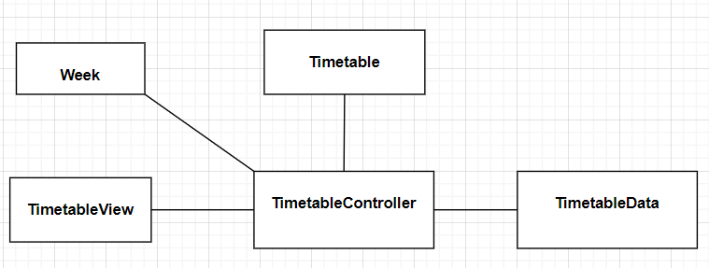

2.2.2. Details

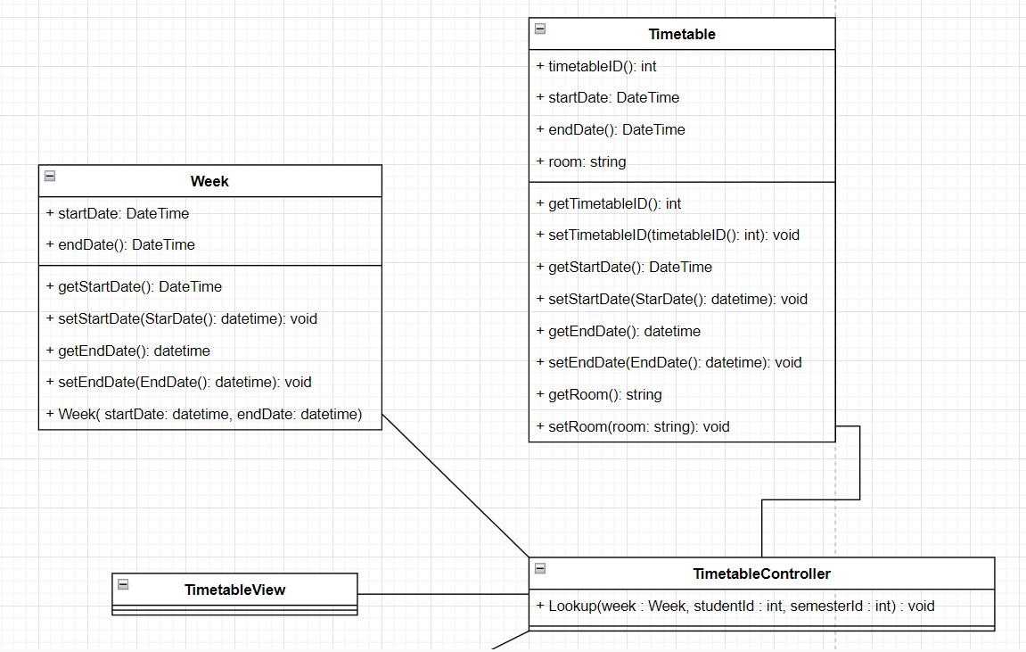

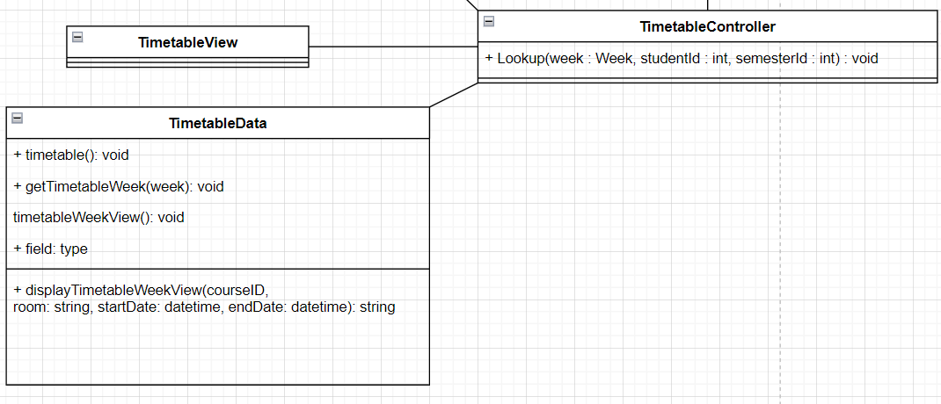

## Sequence diagram

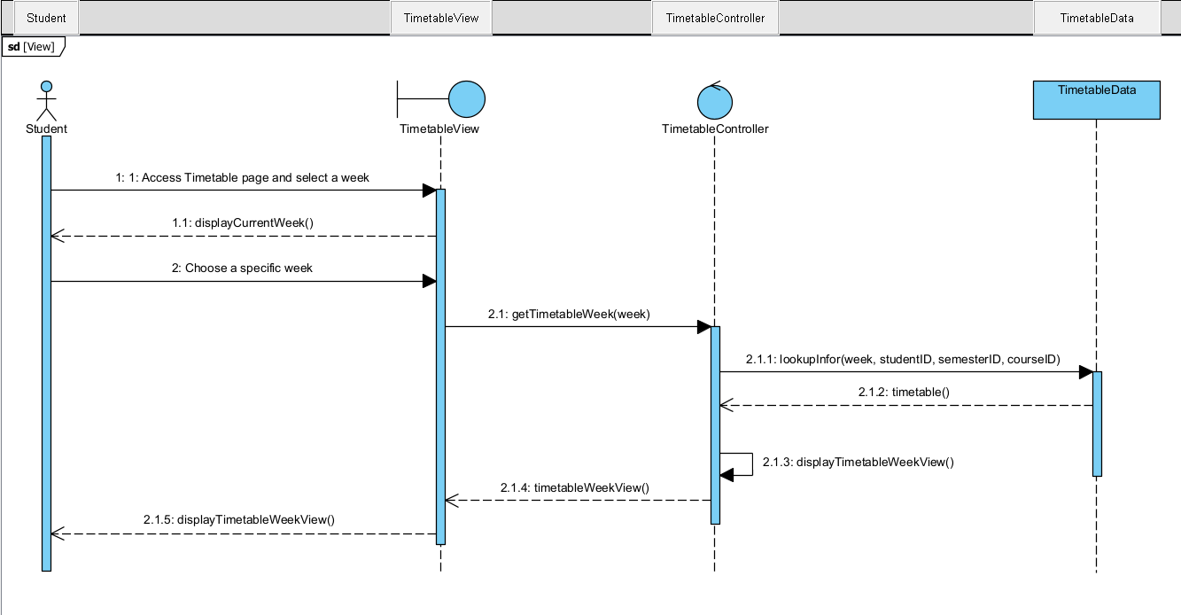

# Derived Requirements

* Display manner: The view should be able to switch back and forward between showing only course class information and showing all details of each course class. The Timetable has to display the blank when students did not enroll in any courses.